**Java 8 Concepts**

* Java is a Object Oriented programming language.
* We enable functional programming language in Java with the help of

Lambda expression to write concise code.

**Java 7 Code**

**----------------**

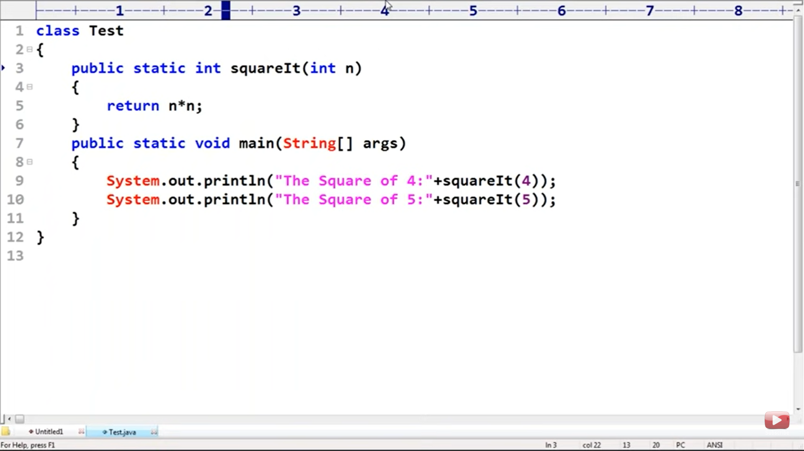

**Java 8 Code**

**-------------**

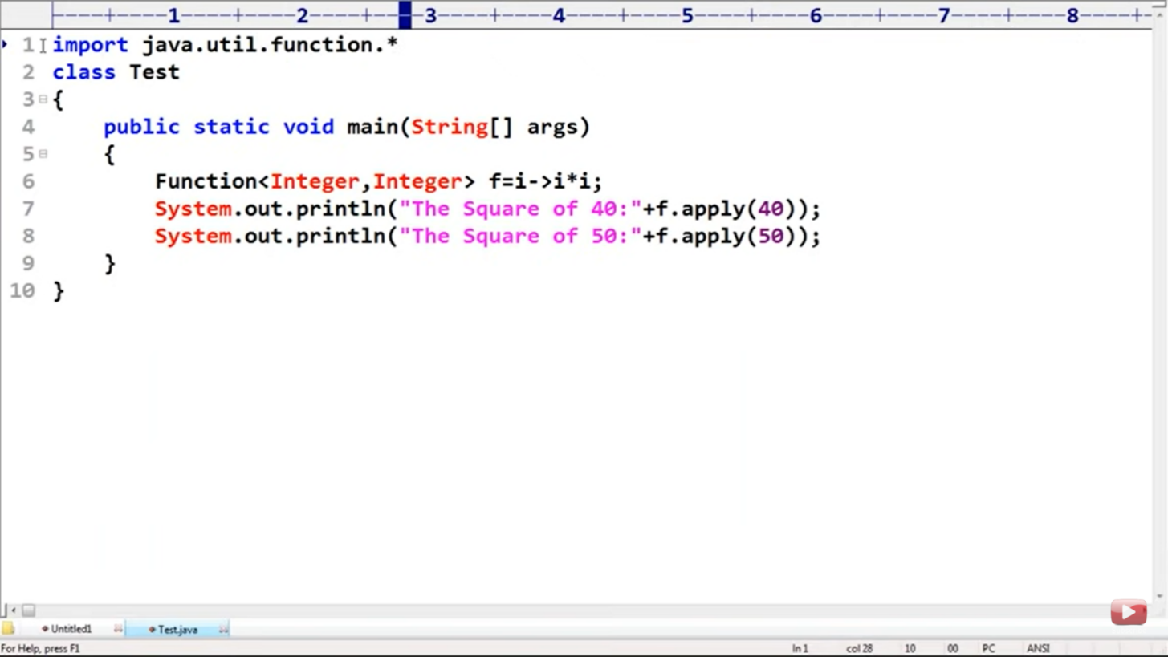

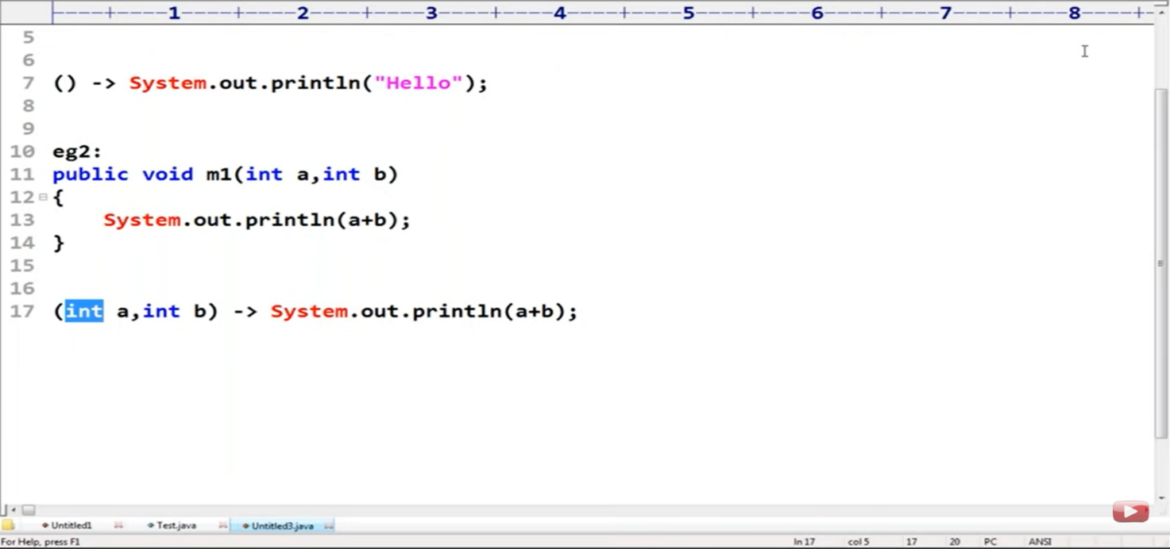

Important :

* If there is only one line of code then curly braces are not required.
* If we are removing curly braces then “return” keyword itself is not required.
* If we are writing “return” keyword then curly braces are required.
* If there is only one parameter in the method , then parentheses is not required.
* Within curly braces If we want to return some value compulsory we should use return statement.

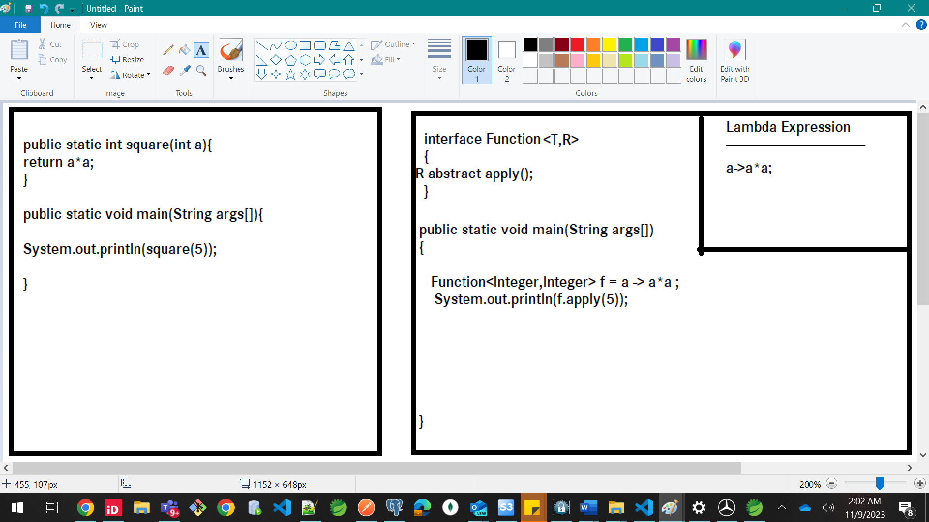

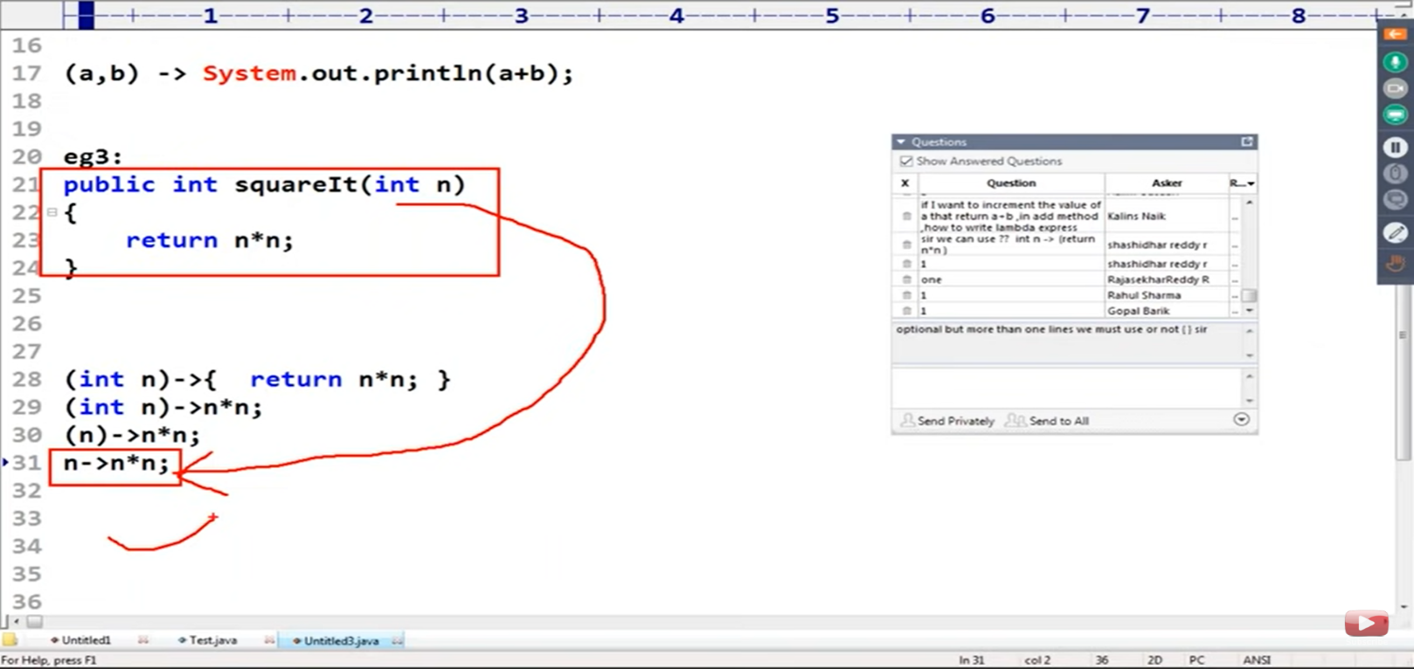

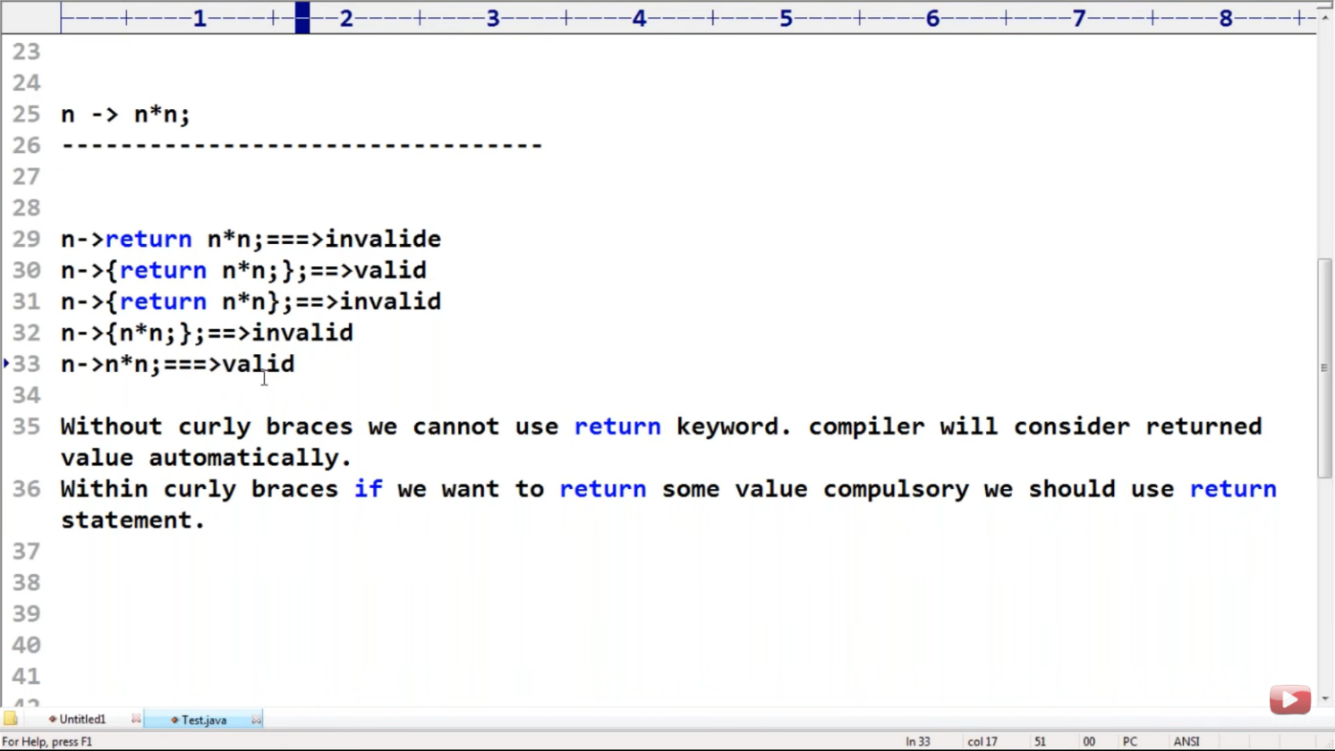

So this is the lambda expression we have written till now.

Now , How to call this lambda expression to execute the expression ?

* In order to call lambda expression to execute statements we need to use Functional Interface

What is Functional Interface ?

* An Interface that contains single abstract method .
* @FunctionalInterface . It is an optional keyword that signify an interface to be a functional.
* If an interface is an functional interface then it must have one abstract method inside it.
* If you want to invoke lambda expression compulsory Functional Interface is required.

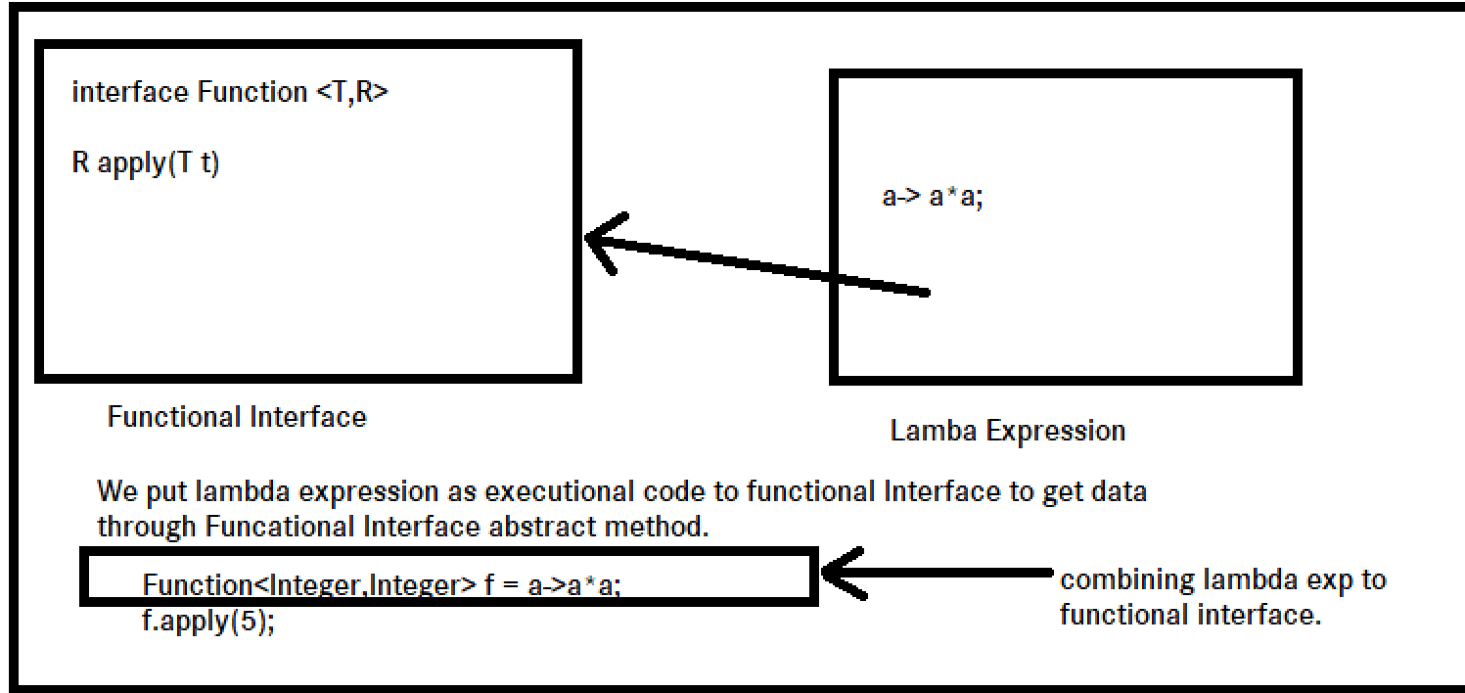

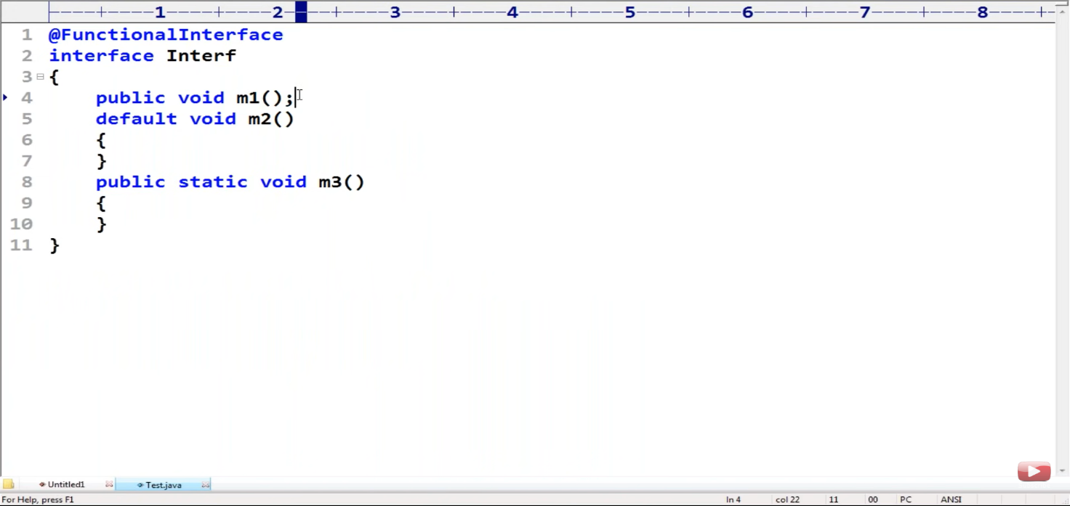

Valid

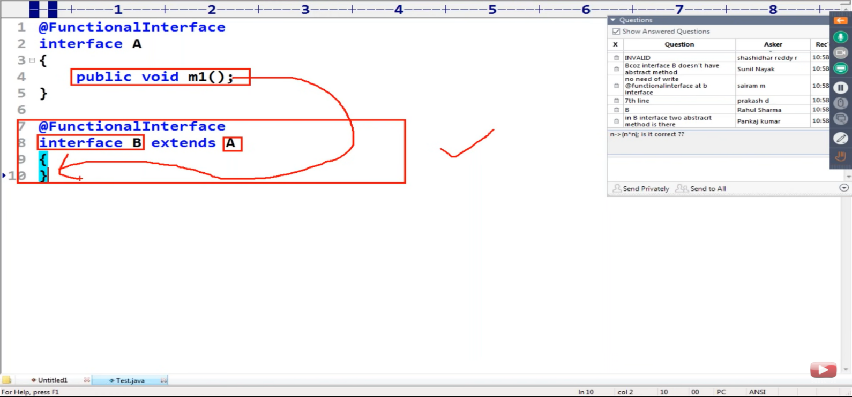

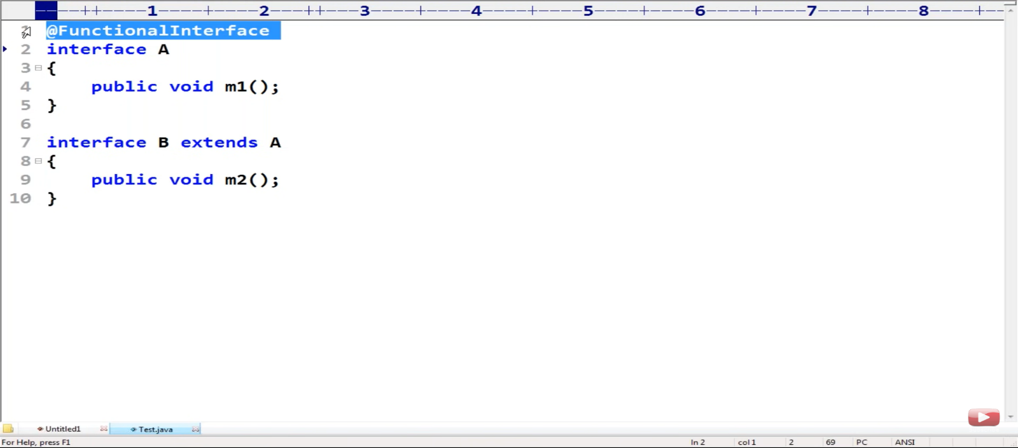

Valid as second interface is not a functional Interface .

Before Functional Interface , We write one extra class for implementation of interface abstract method .

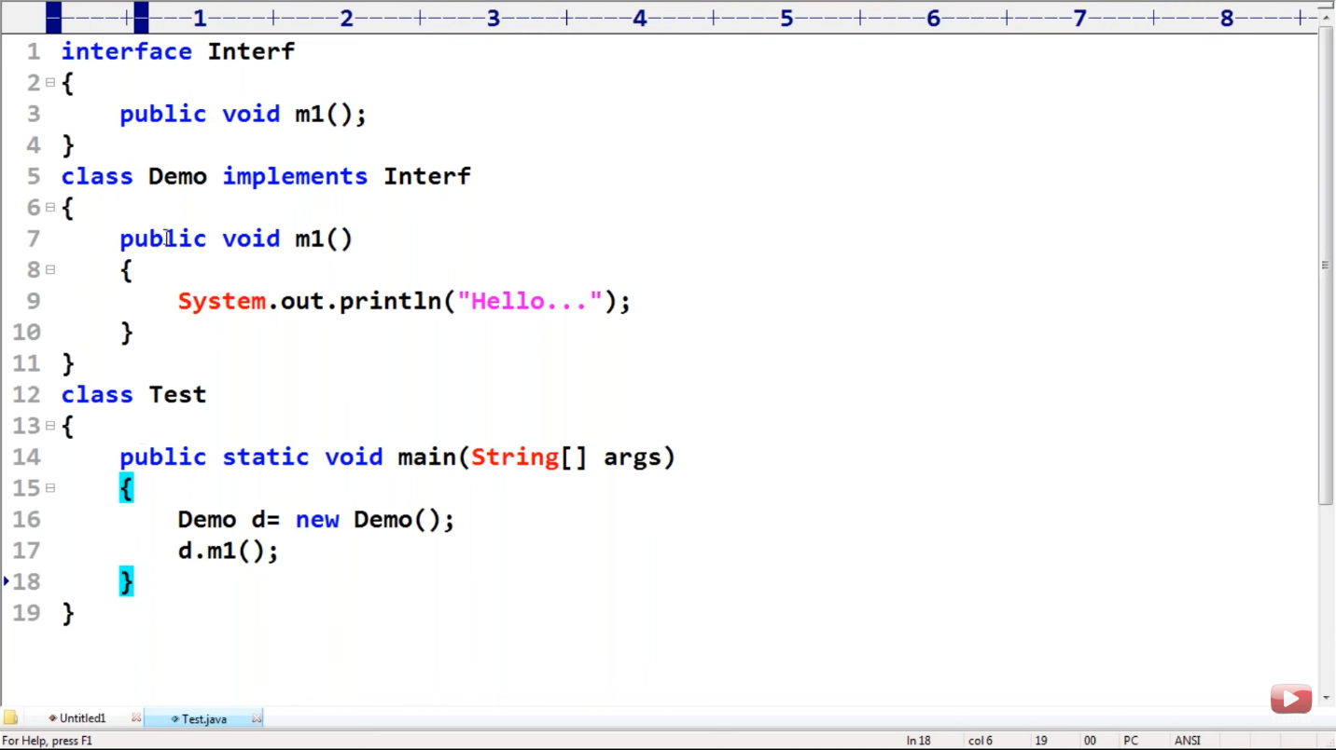

This code can be further optimized and can be written as :

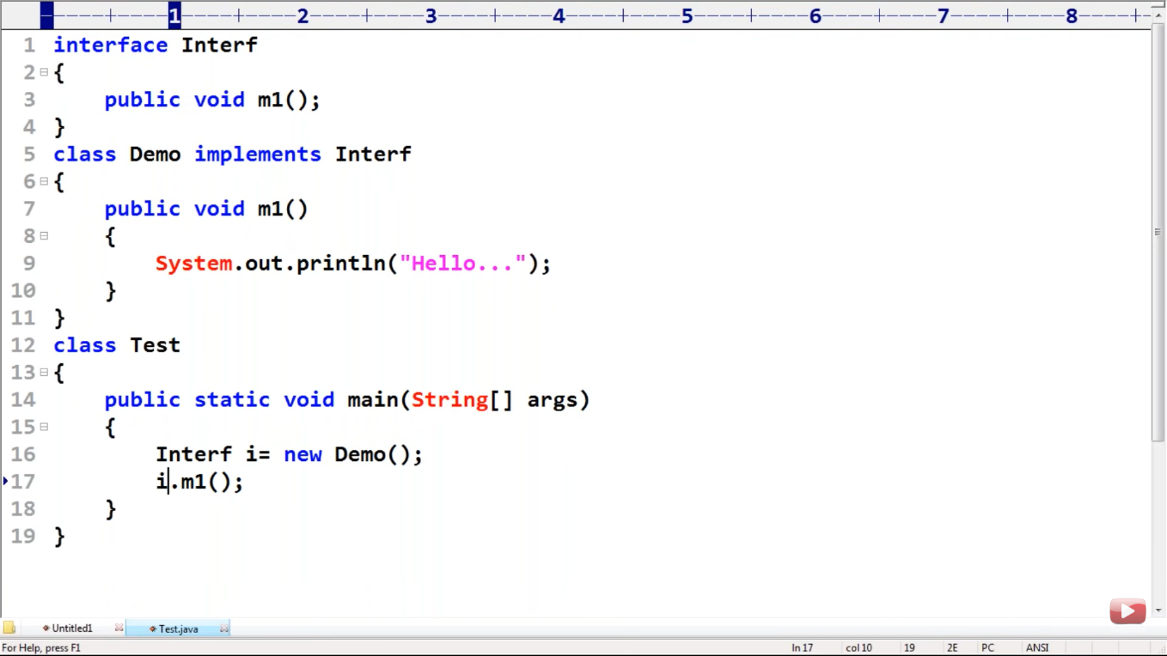

Here interface will be referenced to the object of the class. And with that reference We can call the method.

And Finally when we will remove the extra class code with lambda expression. It will look like.

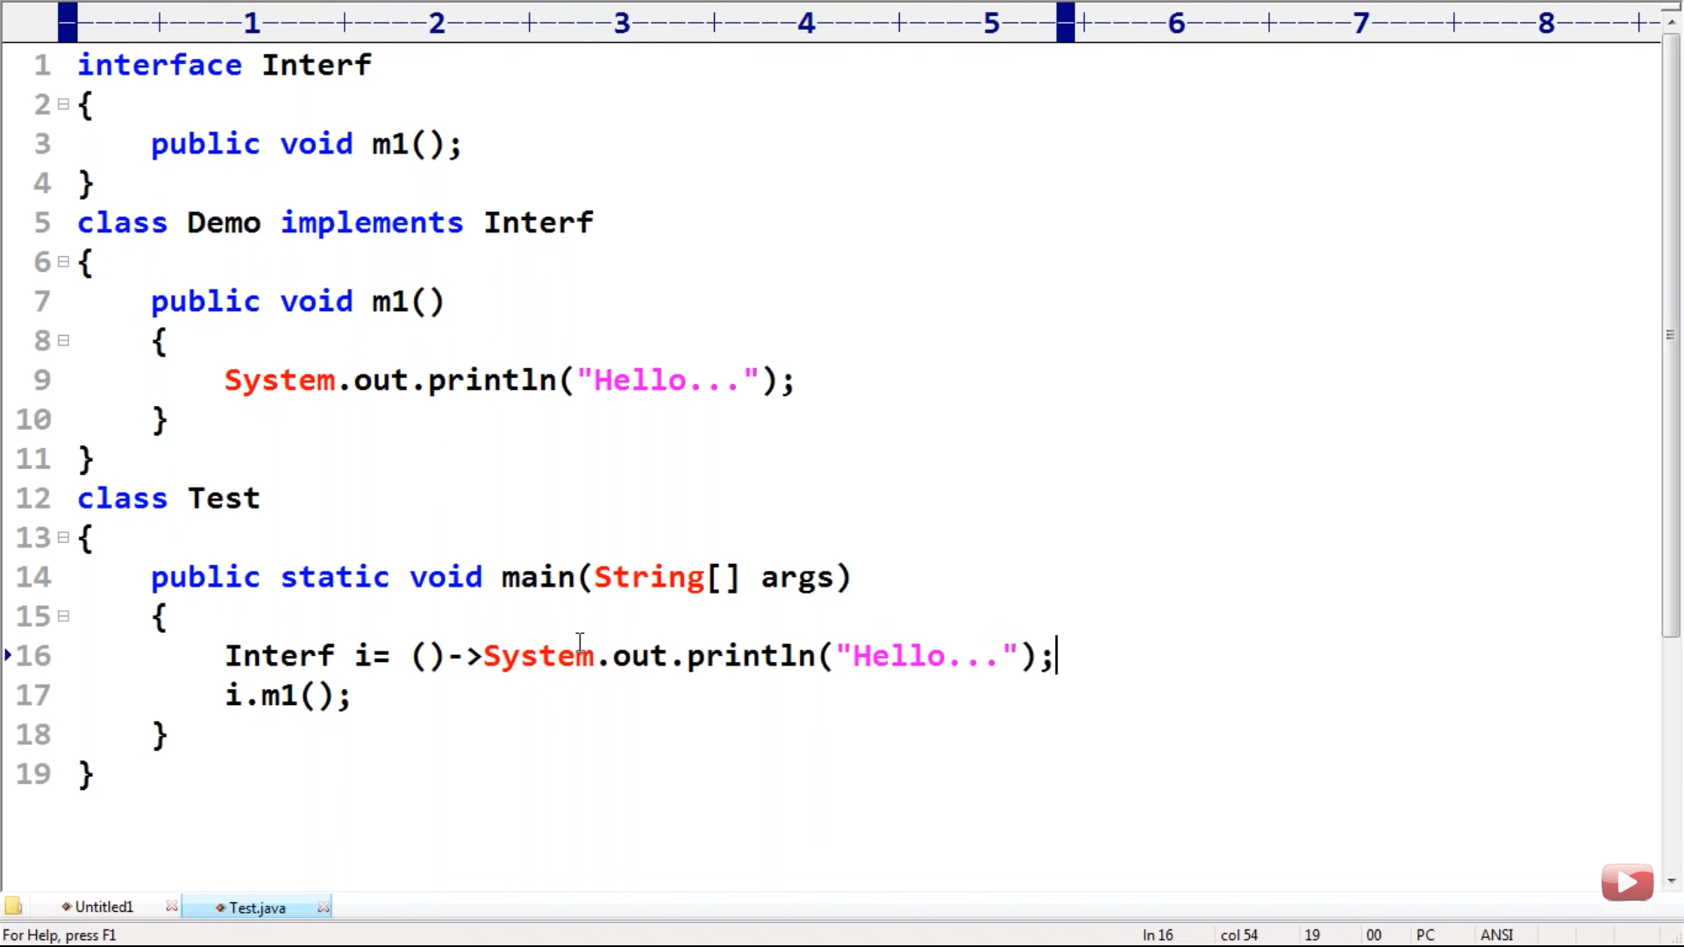

So we don’t need Demo class In the above example.

Final code :

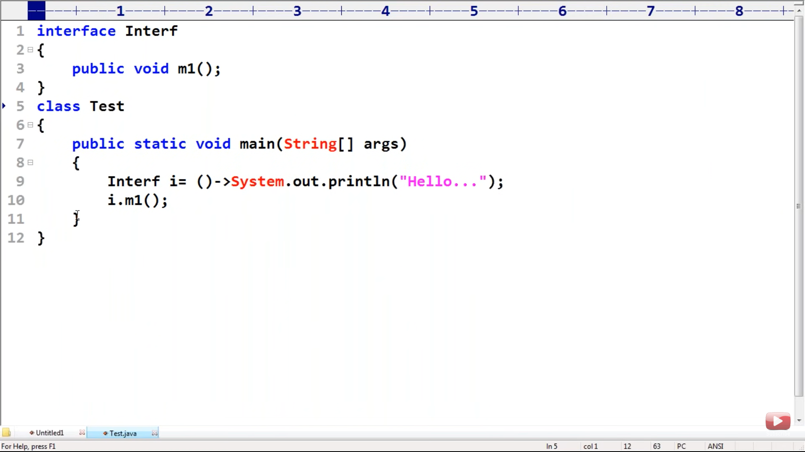

Note :

* To provide reference to the lambda expression , Functional Interface is require.
* () this bracket in Line no 9 of above code , signify the abstract method of interface

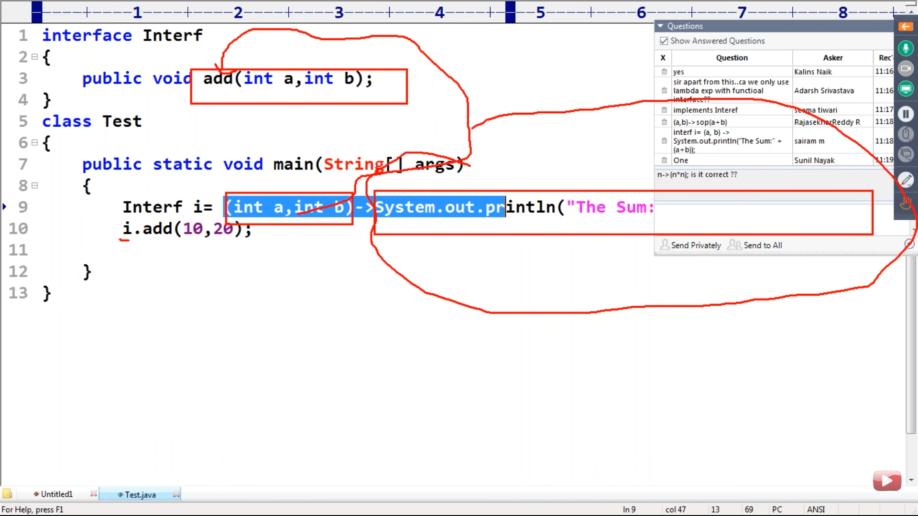



On Removing all unnecessary line of code :

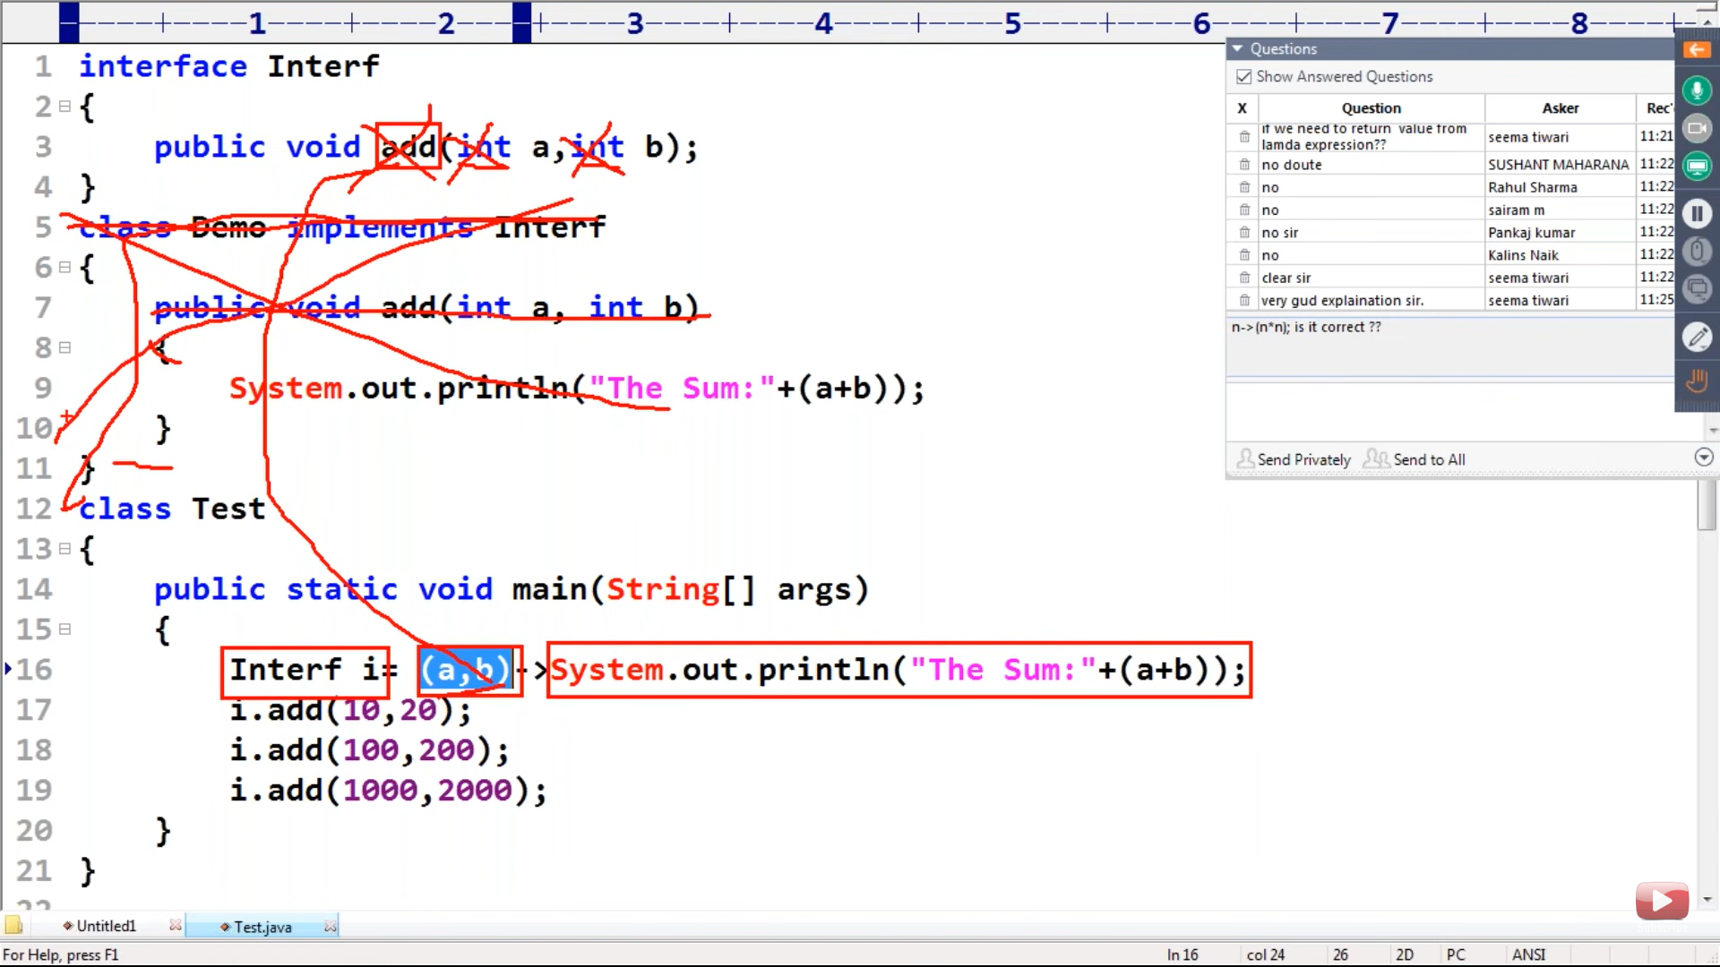

* Here no need to write add method on line 16 as by default we are referring that method only .
* No need to write separate implementation class for abstract method in interface,

as we can write directly at Interface reference( Line no 16 ).

* Lambda expressions concept is only applicable for Functional Interface.
* No separate .class file will be generated for Lambda Expression

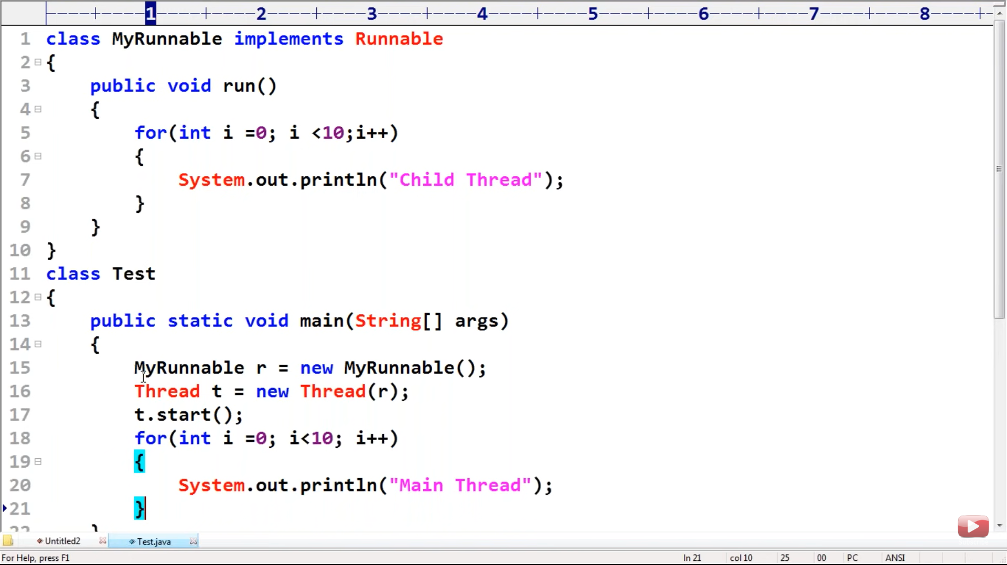

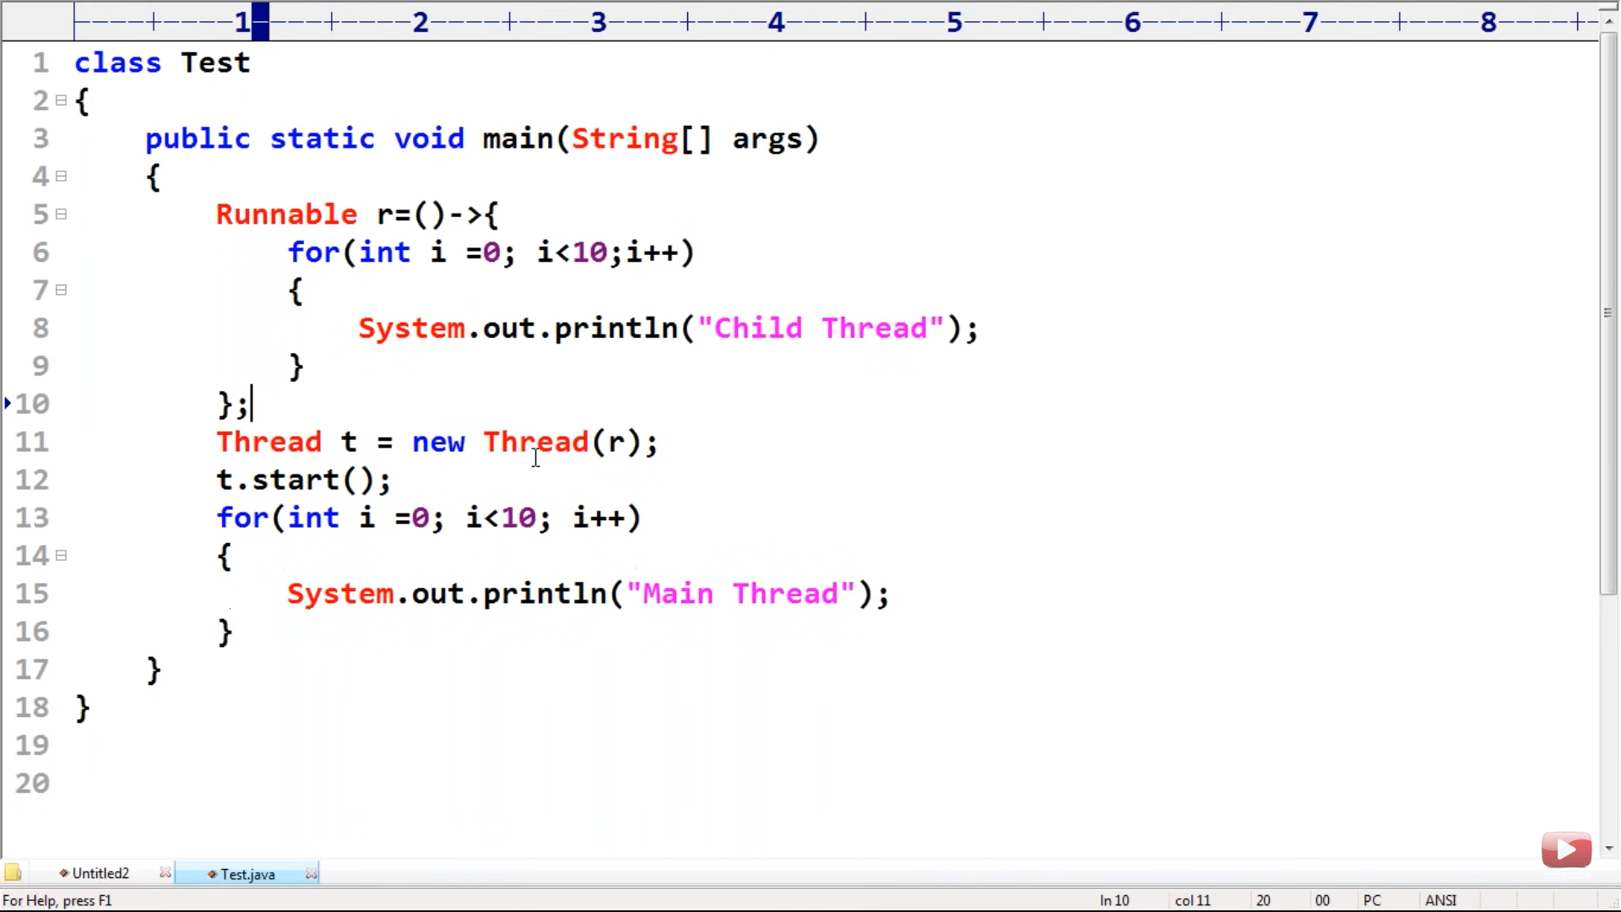

We can use lambda Expression in Collection Sorting Concept also.

As We will use comparator class there which is a Functional Interface.

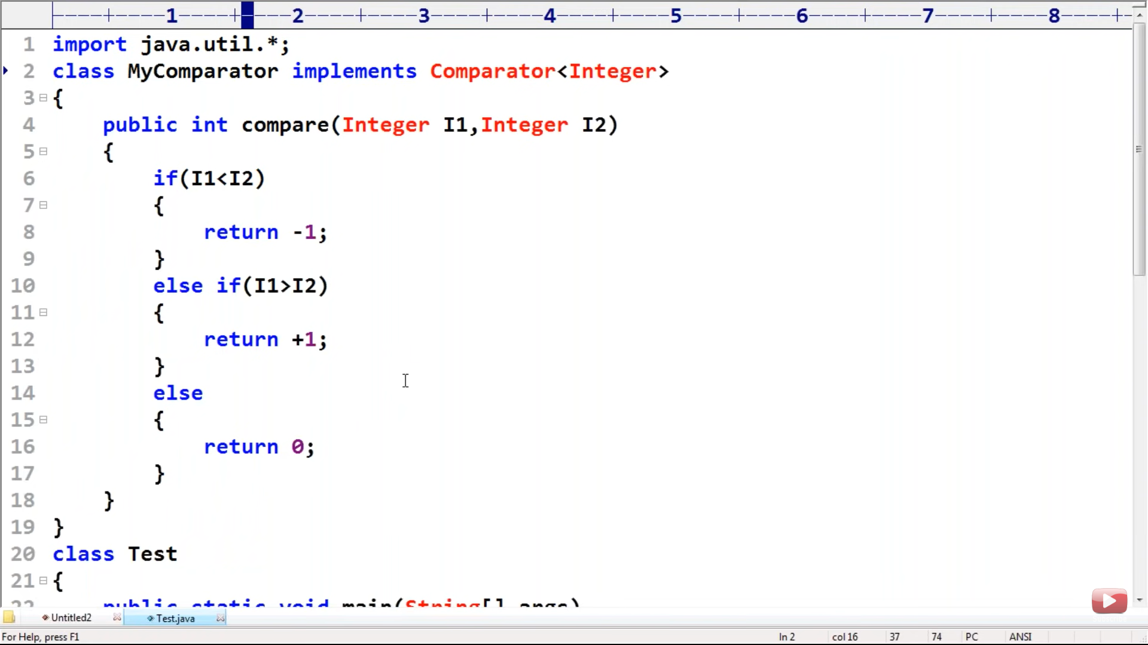

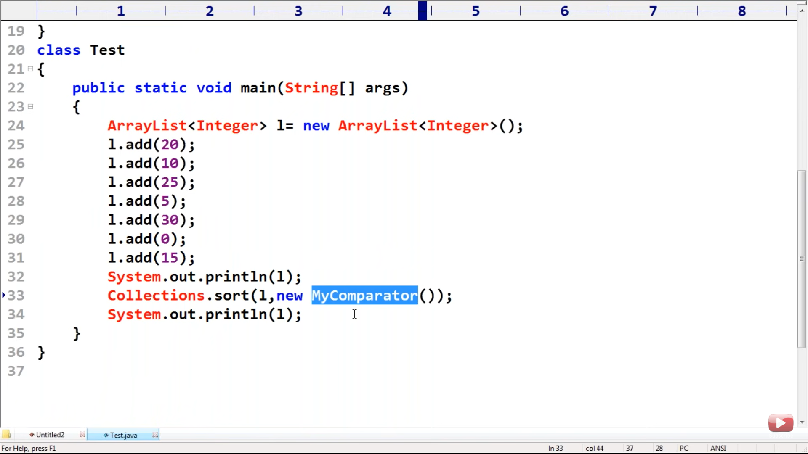

This MyComparator class we can further Optimise with ternary operator.

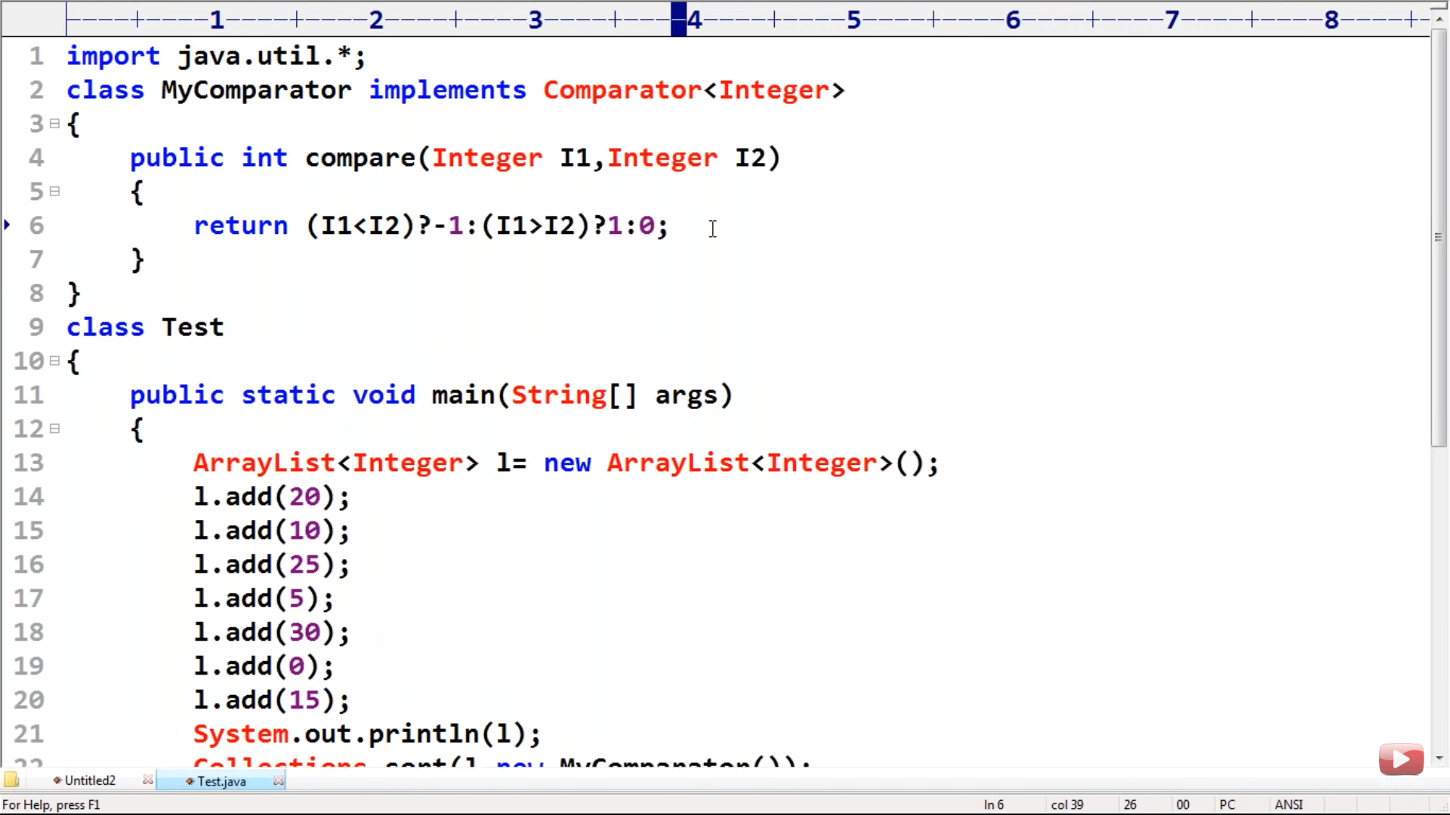

Lambda Expression for MyComparator compare method we can write in the next step:

(Line no 9)

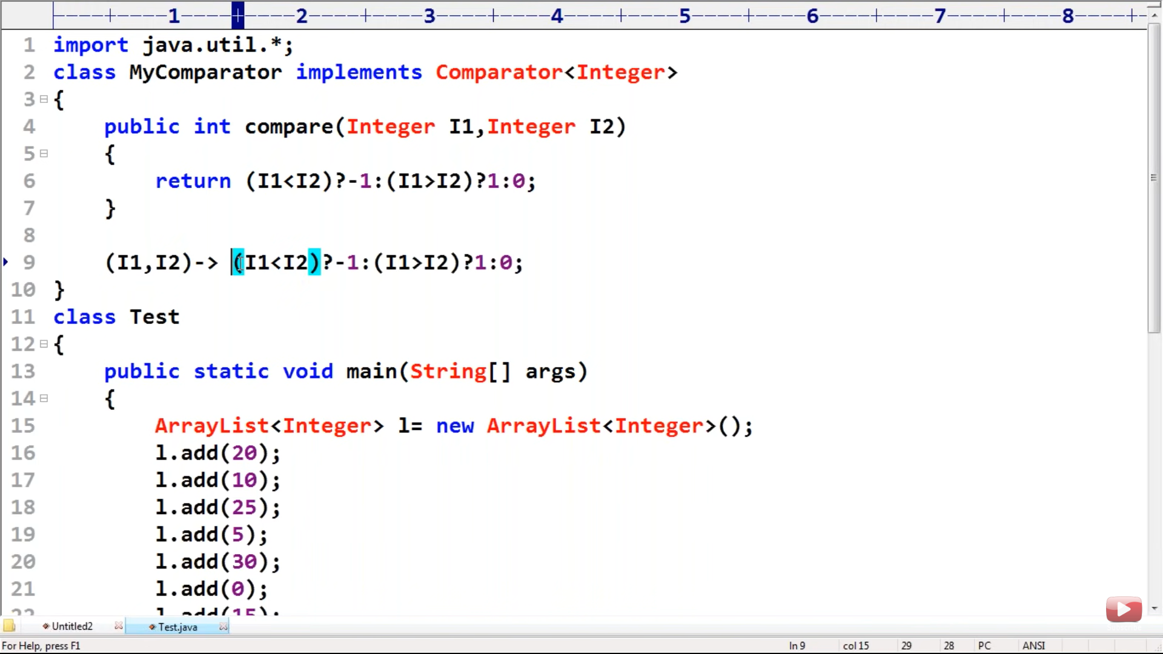

And the Final Code after Implementing sorting with comparable interface using lambda expression.

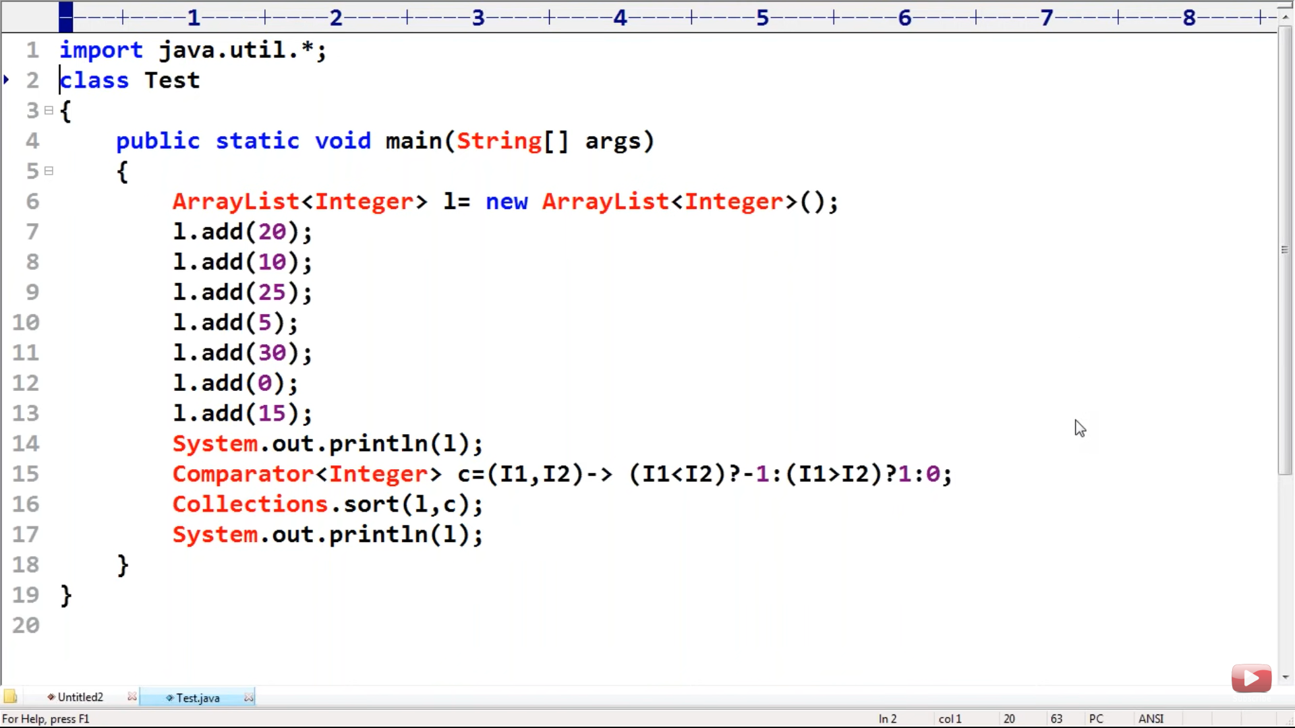

Anonymous Inner Class

-------------------------------------

A class without any name but have implementation is called anonymous Inner class.

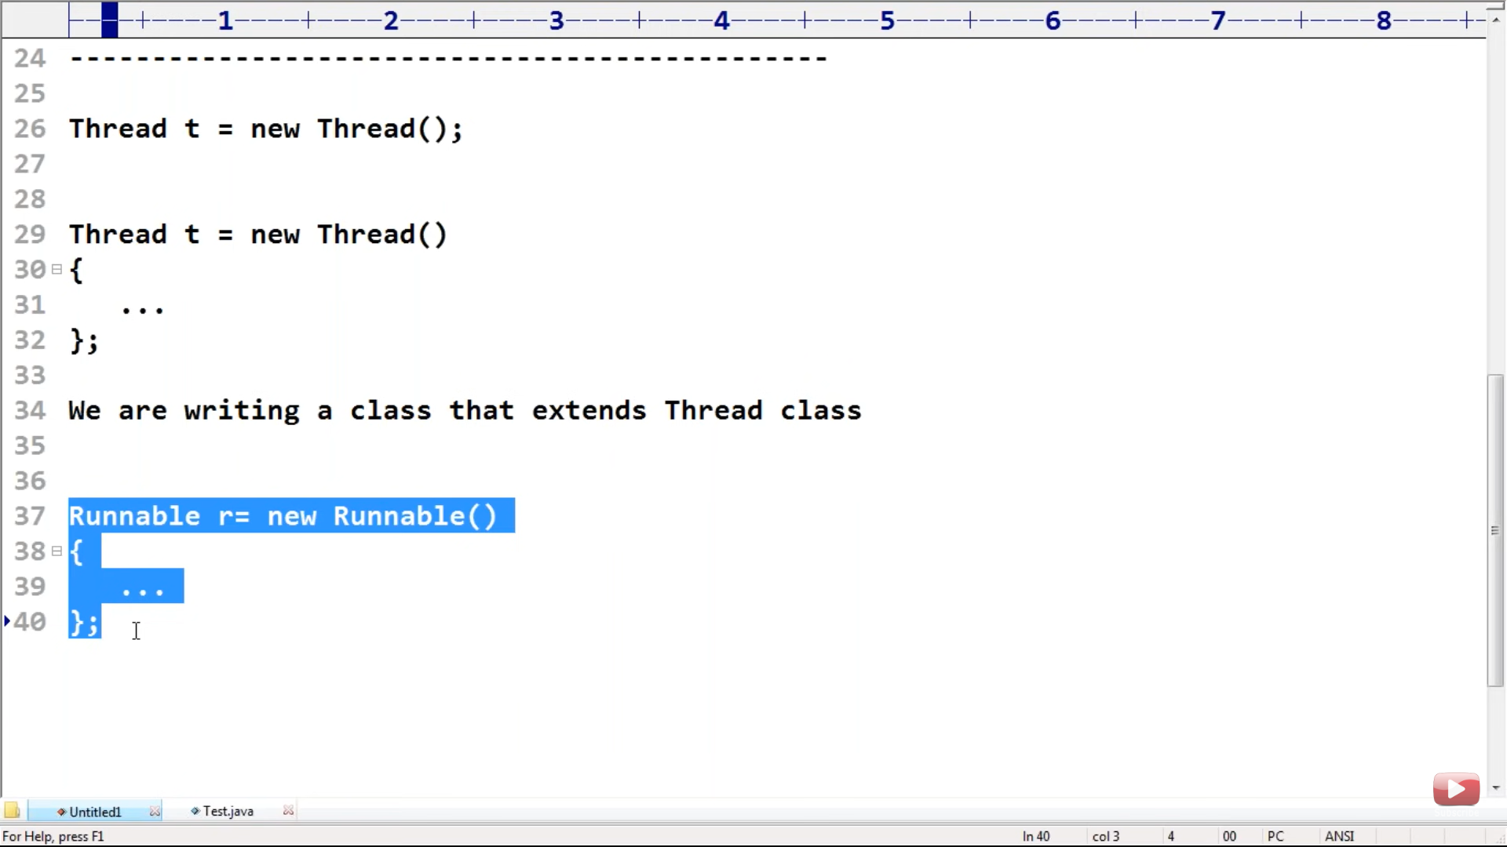

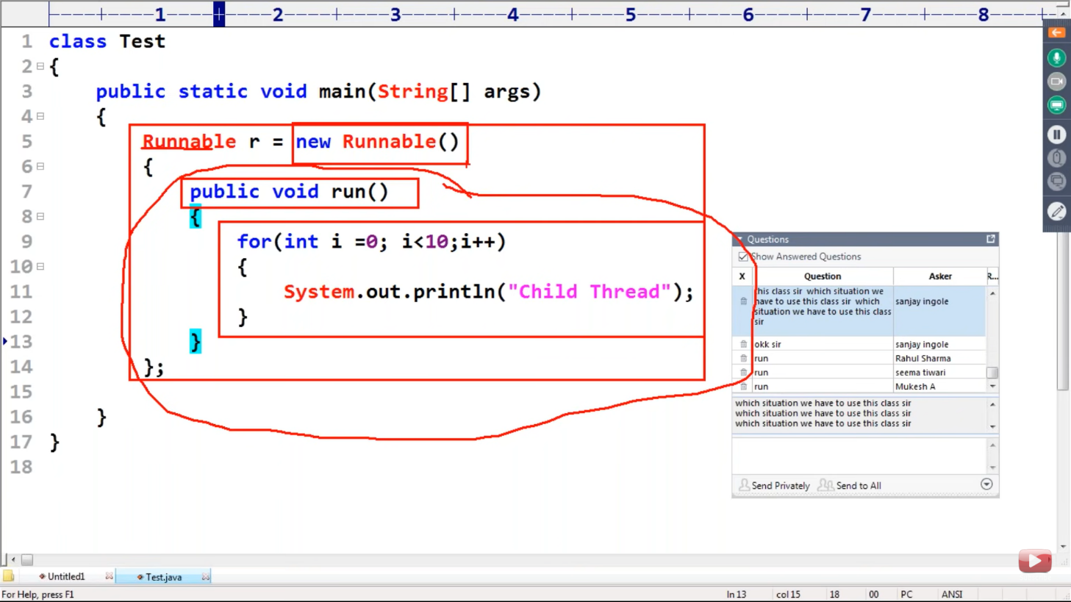

Explanation

--------------------------

For the above , Screenshot , What steps are actually happening there ,

1. We are writing a class that implements Runnable Interface.
2. Providing an implementation for run method .
3. For that implementation class we are creating object with new keyword.

Lambda Expression Inside Anonymous Class

-------------------------------------------------------------------------

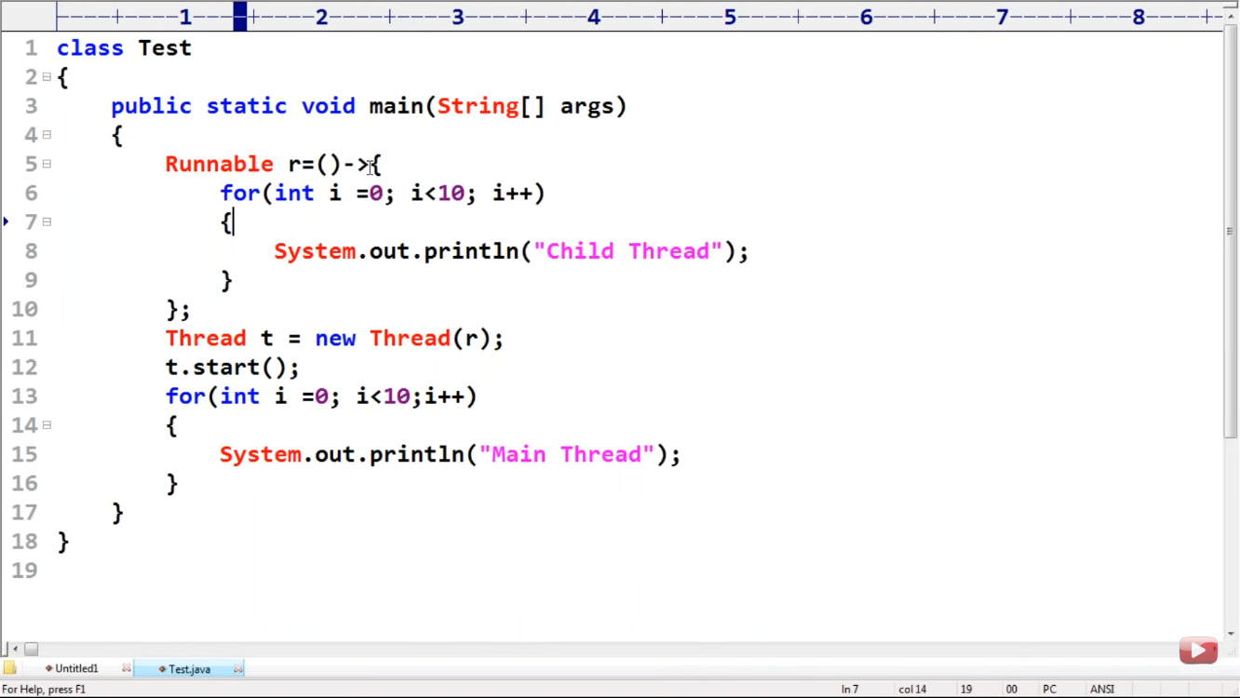

Anonymous Inner classes are more powerful than Lambda Expression.

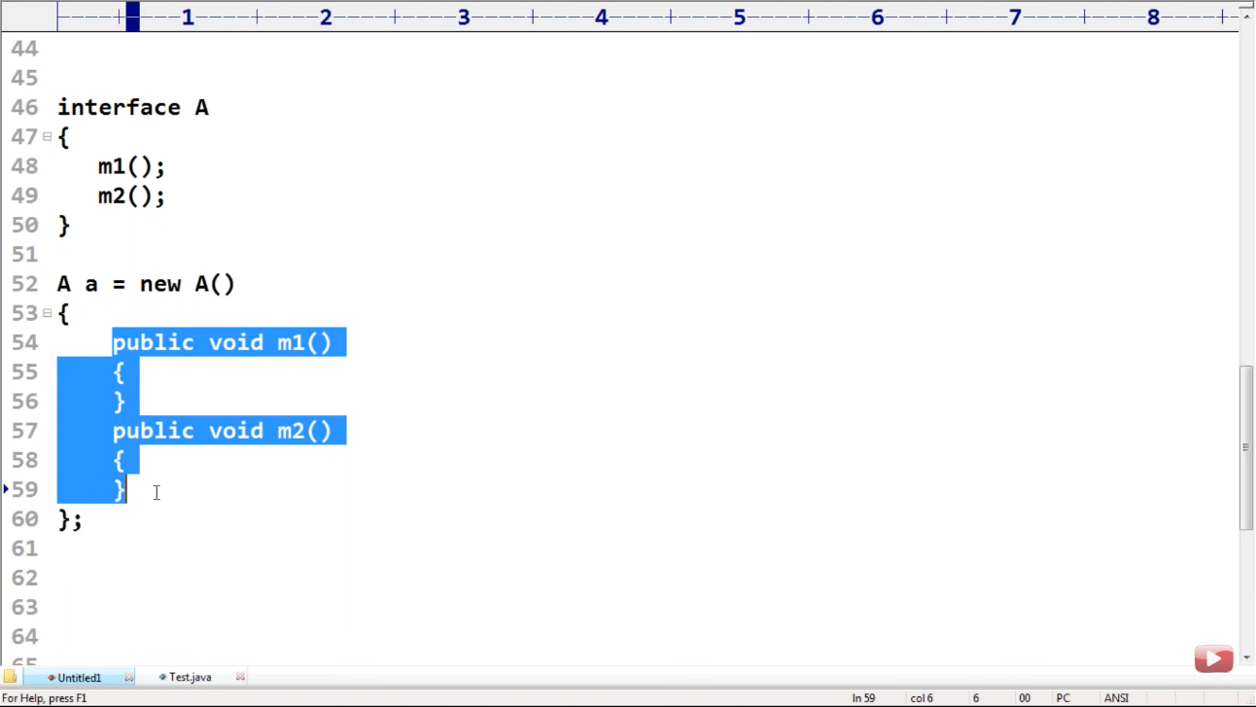

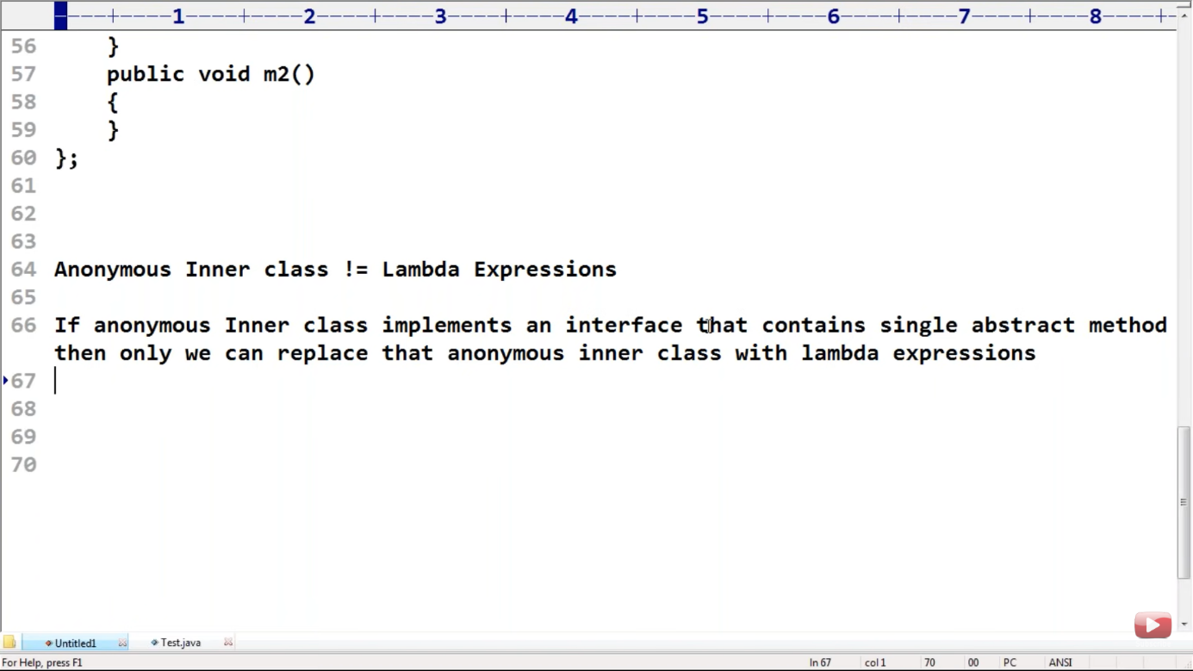

Anonymous class vs Lambda Expression.

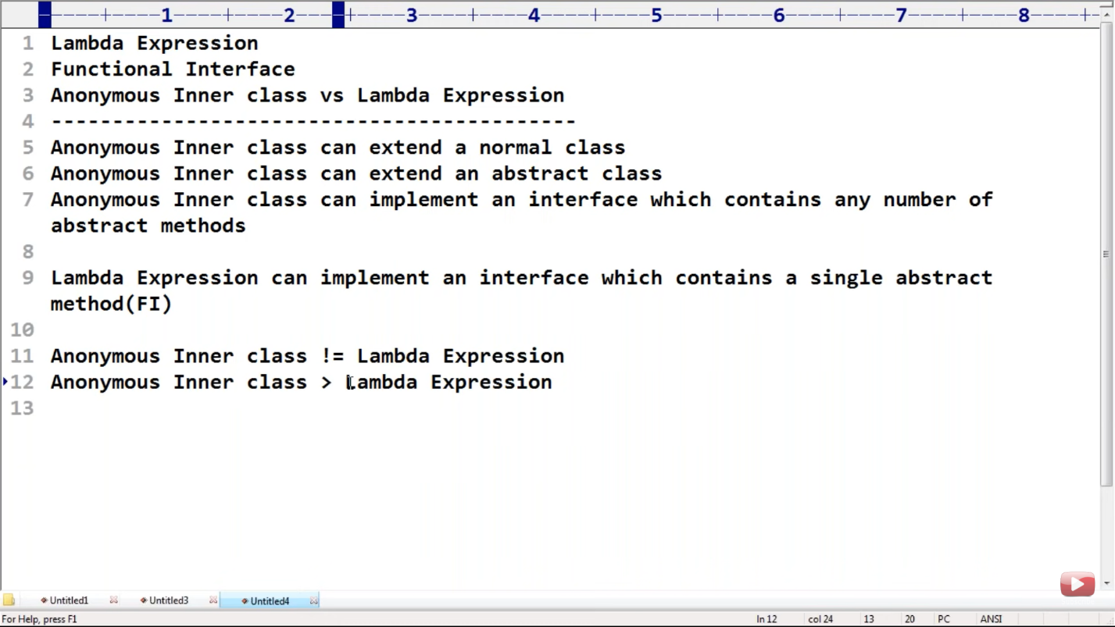

Note :

* Every variable present inside interface is always public static final .
* For Every method :

